**Normalization Example**

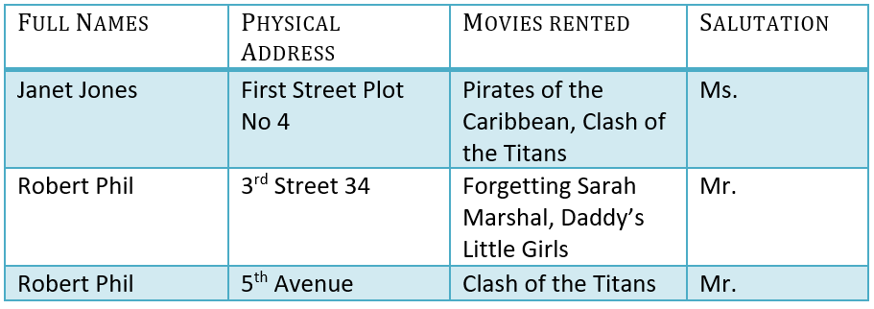

**1NF (First Normal Form) Rules**

* Each table cell should contain a single value.
* Each record needs to be unique.

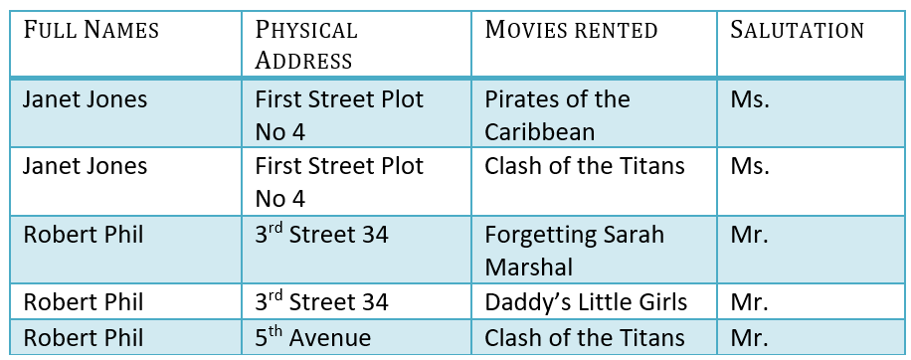

**2NF (Second Normal Form) Rules**

* Rule 1- Be in 1NF
* Rule 2- Single Column Primary Key that does not functionally dependant on any subset of candidate key relation

It is clear that we can’t move forward to make our simple database in 2nd Normalization form unless we partition the table above.

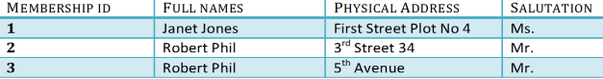

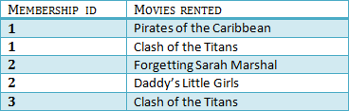

We have divided our 1NF table into two tables viz. Table 1 and Table2. Table 1 contains member information. Table 2 contains information on movies rented.

We have introduced a new column called Membership_id which is the primary key for table 1. Records can be uniquely identified in Table 1 using membership id

## What are transitive functional dependencies?

A transitive [functional dependency](https://www.guru99.com/dbms-functional-dependency.html) is when changing a non-key column, might cause any of the other non-key columns to change

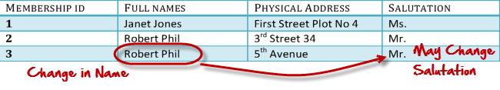

**3NF (Third Normal Form) Rules**

* Rule 1- Be in 2NF
* Rule 2- Has no transitive functional dependencies

To move our 2NF table into 3NF, we again need to again divide our table.

### 3NF Example

Below is a 3NF example in SQL database:

